**DAILY ONLINE ACTIVITIES SUMMARY**

|  |  |  |  |  |
| --- | --- | --- | --- | --- |
| **Date:** | | **16-06-2020** | **Name:** | **Latika Kavoor** |
| **Sem & Sec** | | **4th Sem & A-Section** | **USN:** | **4AL18CS035** |
| **Online Test Summary** | | | | |
| **Subject** | **MATH** | | | |
| **Max. Marks** | **30** | | **Score** | **26** |
| **Certification Course Summary** | | | | |
| **Course** | | **INTRODUCTION TO HTML** | | |
| **Certificate Provider** | | **GUVI** | **Duration** | **6 hrs** |
| **Coding Challenges** | | | | |
| **Problem Statement:**C program to calculate total electricity bill  Write a C Program to perform the following operations on Triply Linked List (TLL) (Note that line is begins from the number 1) (i) Insertion at Front of the TLL (ii) Insertion at End of the TLL (iii) Insertion at front of the specified line (iv) Insertion at the end of the specified line (v) Insertion at the specified position in the specified line (vi) Deletion from the Front of the TLL (vii) Deletion from the End of the TLL (viii) Deletion from the front of the specified line (ix) Deletion from the end of the specified line (x) Deletion from the specified position in the specified line. After each operation, you should display the TLL. For display and Delete operation, you should take care of underflow. No need to check for overflow during insertion, because it is dynamic. | | | | |
| **Status: Completed** | | | | |
| **Uploaded the report in Github** | | | **Yes** | |
| **If yes Repository name** | | | <https://github.com/alvas-education-foundation/latika.kavoor/tree/master/coding_solutions> | |
| **Uploaded the report in slack** | | | **Yes** | |

Online Test Details: (Attach the snapshot and briefly write the report for the same) Math test 5 was conducted on 16-06-2020 from 3:00pm onwards. It was for 40 minutes.There were 15 questions in it each for 2 marks. 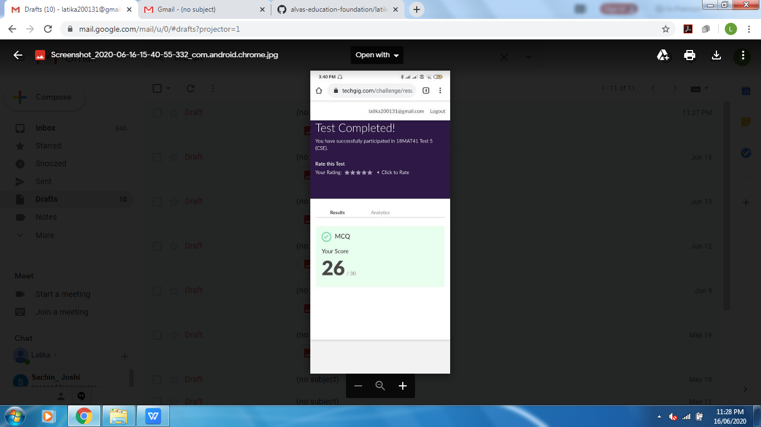

Certification Course Details: (Attach the snapshot and briefly write the report for the same)

I started with HTML course by GUVI nut there is no certificate at the end of it. I have completed 8 videos as of now. I also attended the webinar on THE EMERGING FIELD OF DATA SCIENCE from 4pm to 5pm by Nikhil Shetty.

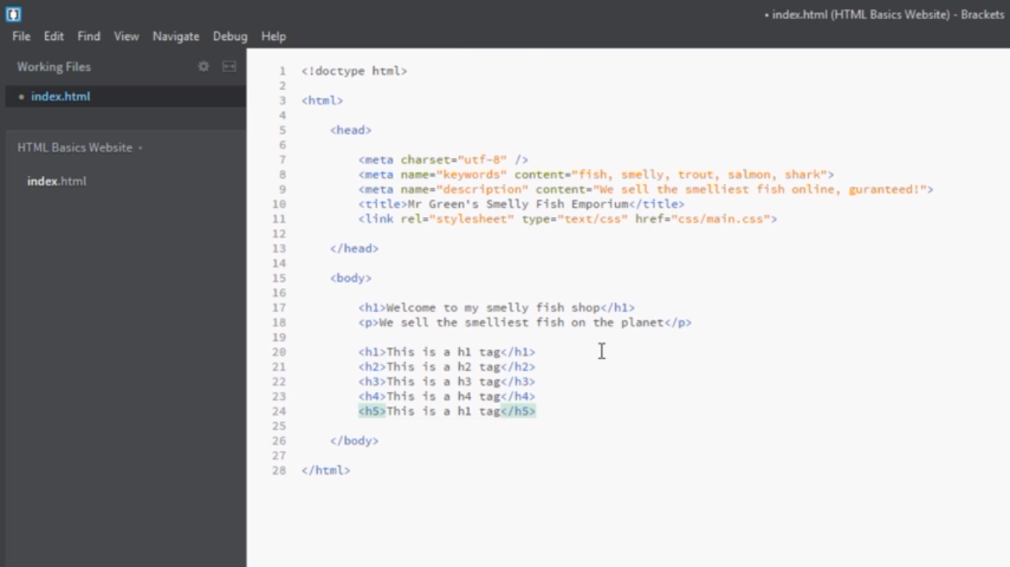

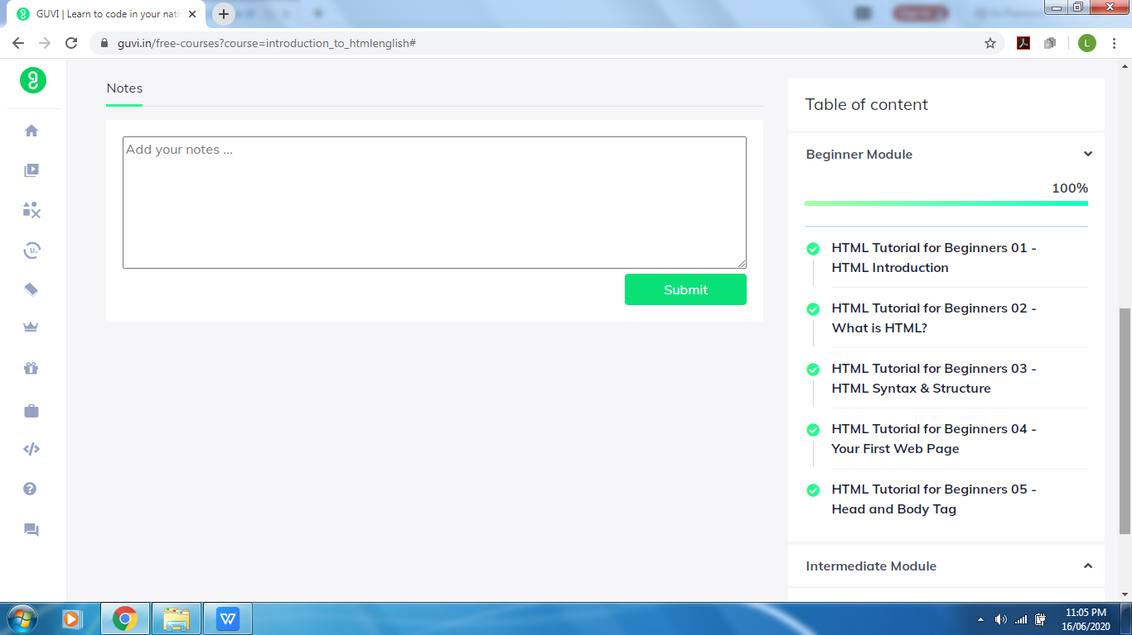

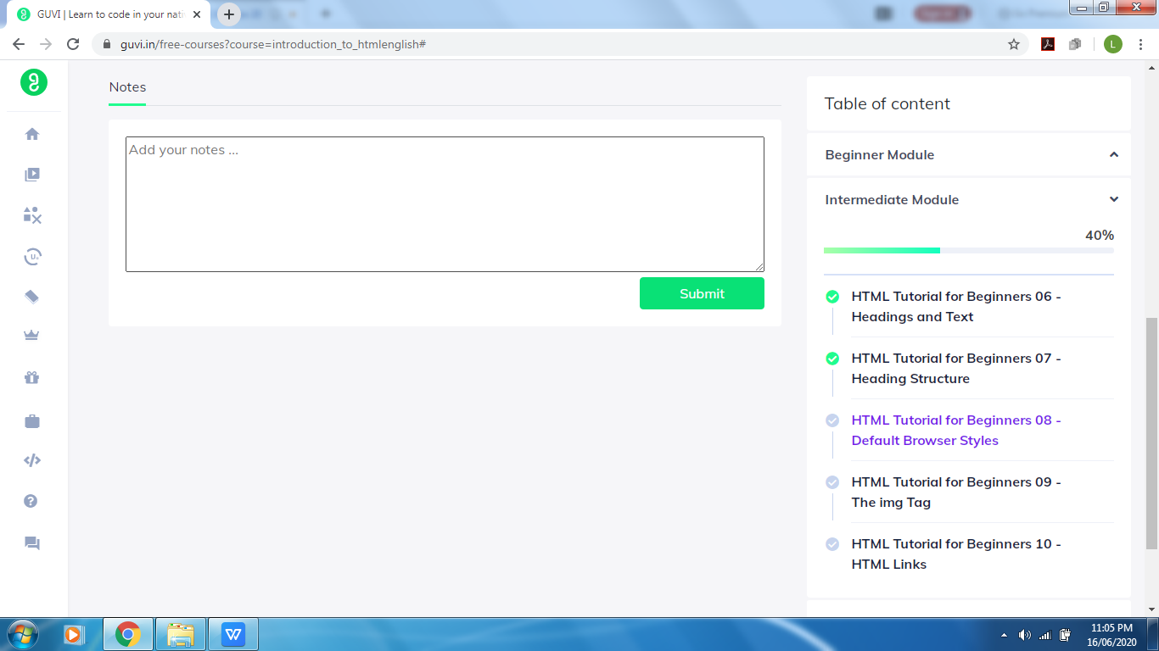

Coding Challenges Details: (Attach the snapshot and briefly write the report for the same)

Solved the problem and uploaded the same on github

